Eclectics Interview Technical Specification Document

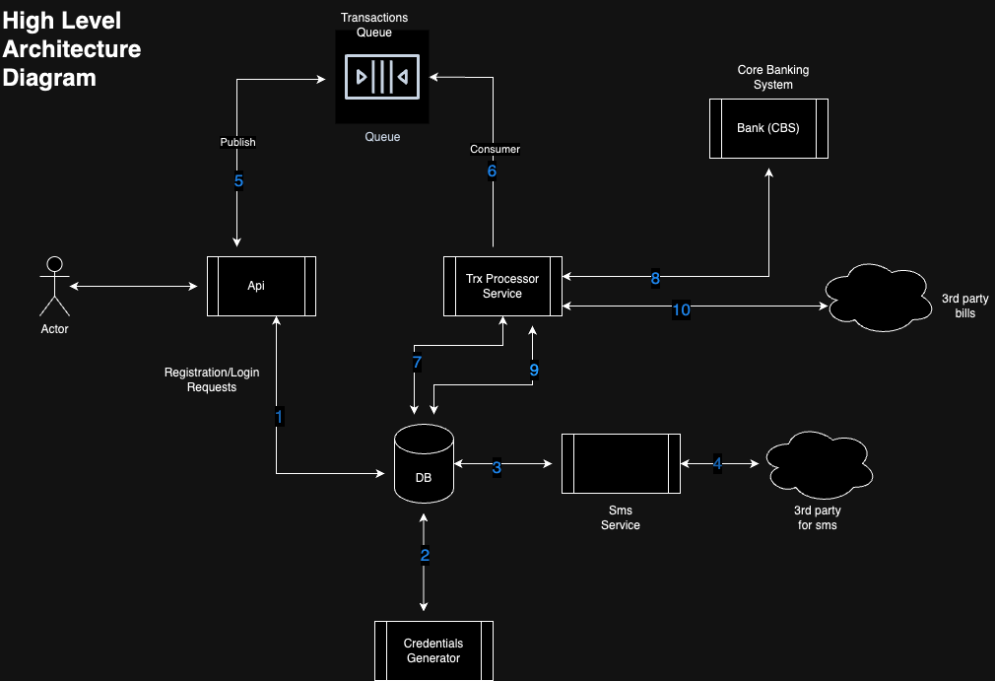

Description
Api - Will handle all incoming requests i.e. Registration, Login & Transaction requests.

- Api handles registration of a new bank customer, receives requests from the actor and saves KYC and dependents to the database. This also create a system user.
- After KYC details have been saved to the database, credentials Generator picks the record from the database, generates a password and updates the DB with that password.
- SMS Service, reads the database, selects new SMSes.
- SMS Service calls a 3rd party SMS provider to send the SMS.
- Api receives transaction requests e.g. money market, shares etc. The Api will publish the request to a trx queue, and Acknowledge back to the user with a message. “Your request has been successfully received, you’ll receive an sms”.
- Trx Processor Service Consumer, consumes the transaction message for further processing.
- Trx Processor Service Consumer saves record to database.
- Trx processor sends request to Core Banking system, CBS will process the request and respond with either success or fail. (Assumption CBS process is Sync)
- After getting the response from CBS, transaction status is updated to the database and sms record also inserted to the sms table.
- If 8 above is successful and it’s a bill, it's further sent to a 3rd party vendor api e.g KPLC Tokens.

